### [**whitehouse.gov**](https://www.whitehouse.gov/)

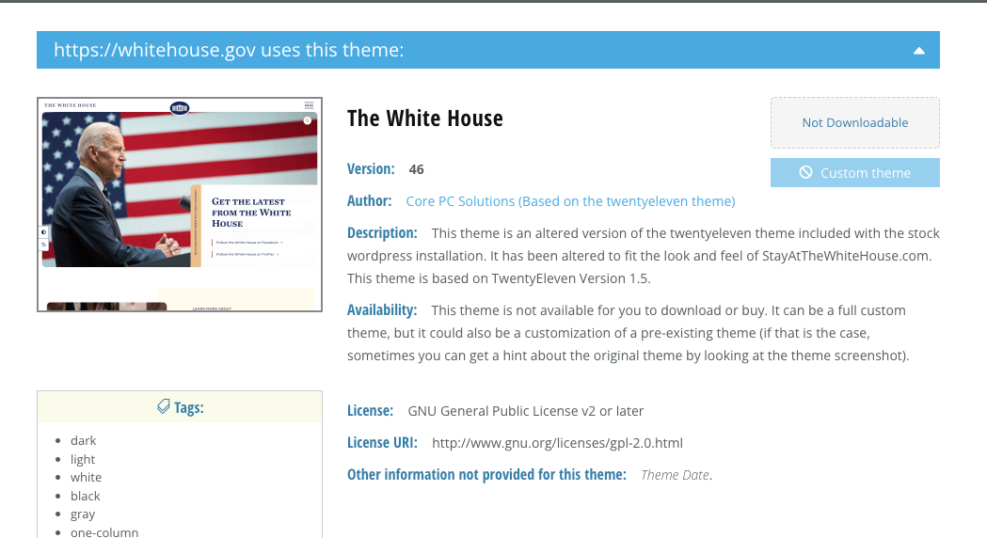

### [**jquery.com**](http://jquery.com/)

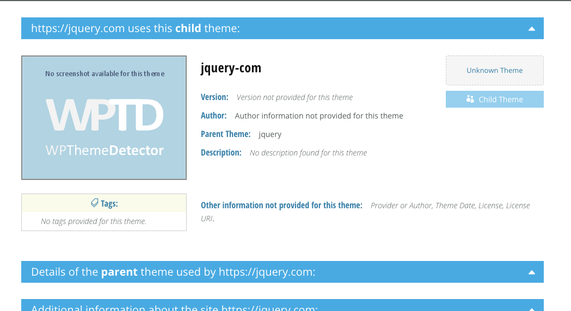

### [**plesk.com**](https://www.plesk.com/)

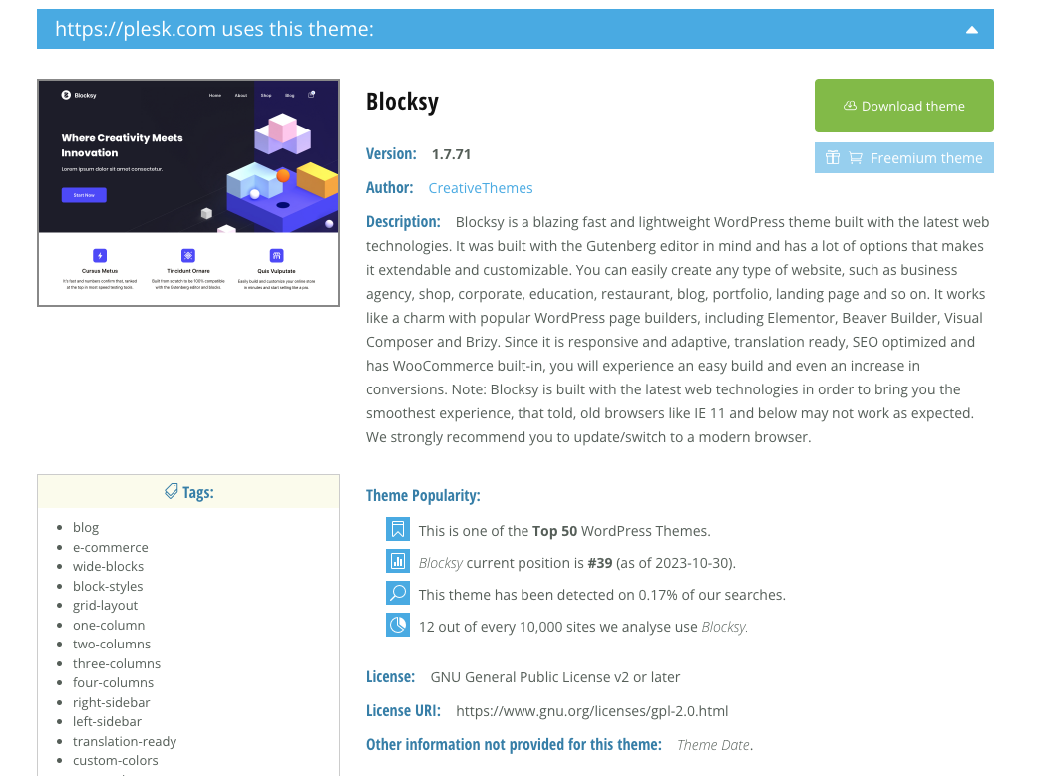

### [**quantcast.com**](https://www.quantcast.com/)

### 

### 

### 

### 

### 